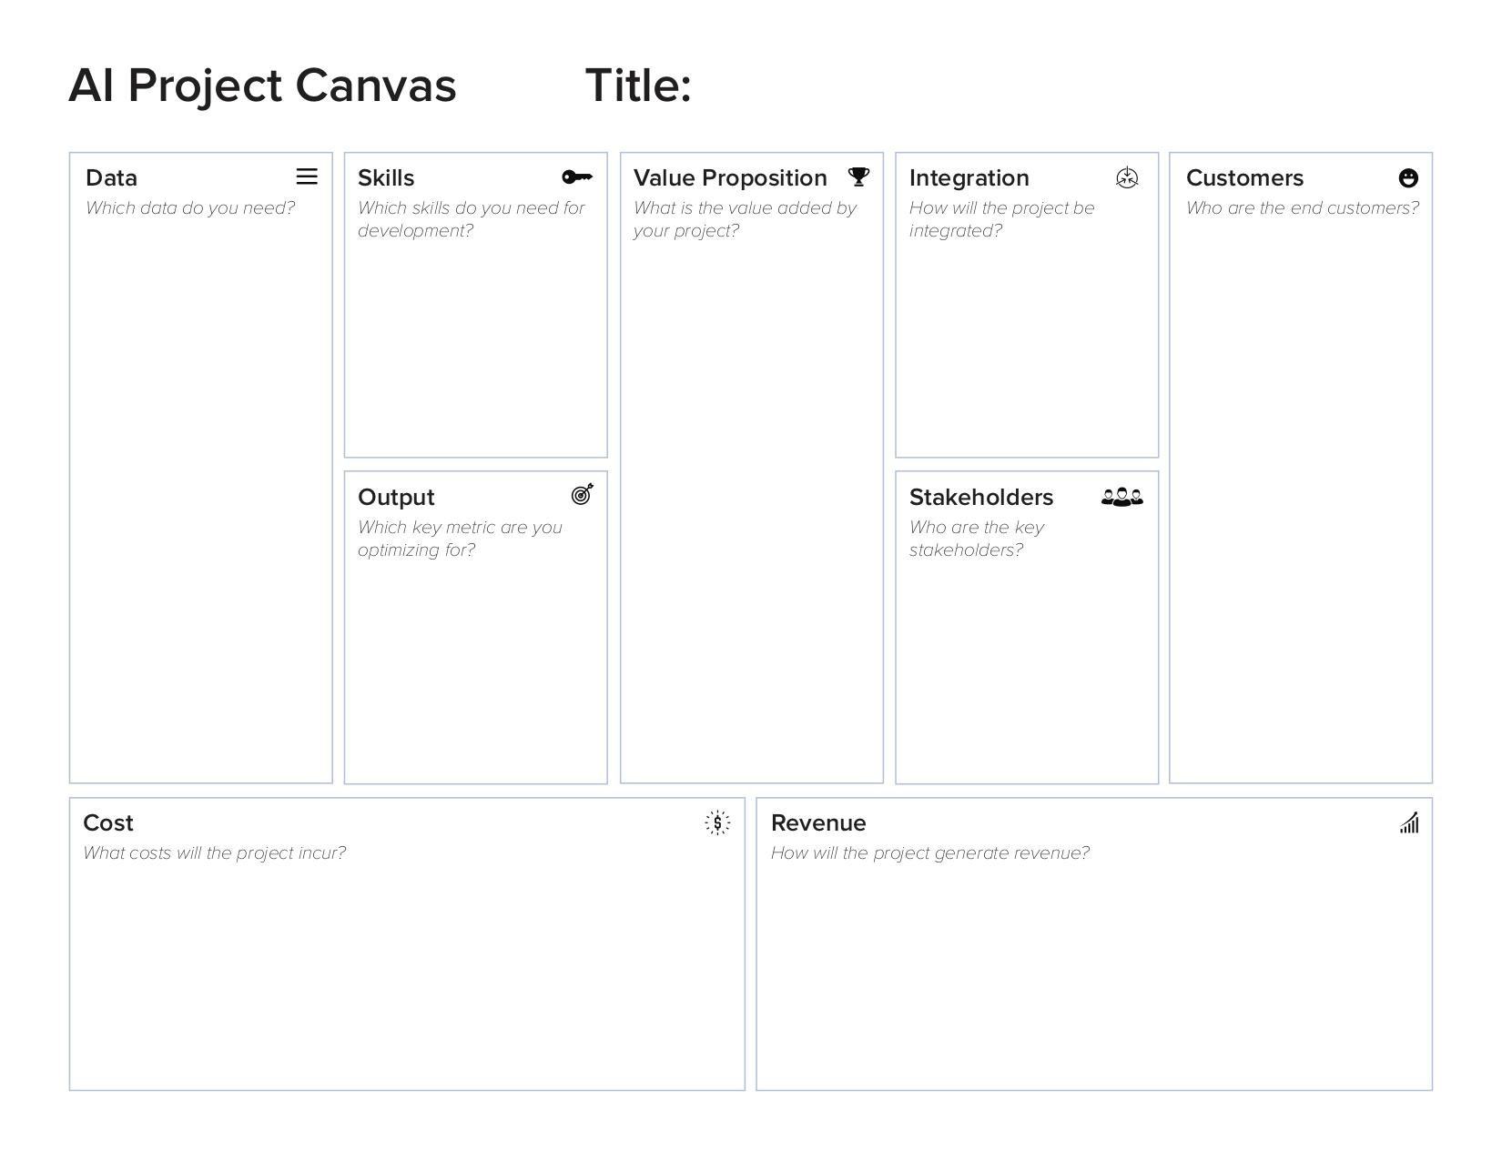
Accident probability calculator
The app is meant to prevent various incidents in the city under certain weather conditions and in areas where incidents often take place, or where actions like speeding, harsh braking or sharp turning often occurs.
ANWB Data: Safe driving, weather related data.

Weather data: Real-time, accuweather local weather data

Time Data: Date, holiday, time data
Commuters

City Planners

Emergency Services

Server: The project will need an active server to host the web app, and make the predictions
Data: The live weather API we need to make the predictions will require us to pay after the requests.
Development: The project needs constant attention to keep running and keep the model accurate and up-to-date
Ads: The app includes ads. With using the app users will get ads from different companies and sources.
Subscription: The application will implement limitation to the free version. This way users wanting to use the additional functions will have to purchase the monthly subscription.
Data Analysis

Machine Learning

Web Development

Project Management
Accuracy: Accuracy of prediction potential incidents, their type and severity
ANWB

Municipality of Breda

Commuters

Emergency services
Platform :Smartphone web-app

Tool: Proprietary device

